 | 26.9.15 Editors - Properties Editor - Modifiers Properties Tab - Lattice - Deform Modifiers
Table of content
Detailed table of content 1
Lattice - Deform modifiers 4
Armature 4
Cast 6
Curve 7
Hook 9
Lattice 11
Mesh Deform 11
Shrinkwrap 12
Simple Deform 14
Warp 15
Wave 17

Detailed table of content

Detailed table of content
Detailed table of content 1
Lattice - Deform modifiers 4
Armature 4
Object 4
Vertex Group 4
Invert 5
Preserve Volume 5
Multi Modifier 5
Bind to 5
Vertex Groups 5
Bone Envelopes 5
Cast 6
Shape 6
Axis 6
Factor 6
Radius 6
Size 6
Size from Radius 6
Vertex Group 7
Invert 7
Object 7
Curve 7
Curve Object 7
Deformation Axis 7
Vertex Group 7
Invert 7
Texture Prop 8
Texture browser 8
Texture Edit Box 8
Fake User 8
Add Texture 8
Remove 8
Change Context 8
Coordinates 8
Direction 8
X, Y, Z 8
Space 8
Normal 8
Custom Normal 8
RGB to XYZ 9
Space 9
Strength 9
Mid level 9
Vertex Group 9
Invert 9
Hook 9
Object 10
Vertex Group 10
Invert 10
Strength 10
Reset 10
Recenter 10
Select 10
Assign 10
Falloff 10
Type 10
Radius 10
Uniform Falloff 11
Lattice 11
Object 11
Vertex Group 11
Invert 11
Strength 11
Mesh Deform 11
Object 11
Vertex Group 11
Invert 12
Precision 12
Dynamic 12
Bind 12
Unbind 12
Shrinkwrap 12
Wrap Method 12
Nearest Surface Point + Target Normal Project 12
Snap Mode 13
Target 13
Project 13
Snap Mode 13
Limit 13
Subdivision Levels 13
Axis 13
Negative/Positive 13
Face Cull 13
Target 13
Auxiliary Target 13
Nearest Vertex 14
Target 14
Offset 14
Vertex Group 14
Invert 14
Simple Deform 14
Deform Method 14
Twist 14
Bend 14
Taper 14
Stretch 14
Origin 15
Restrictions 15
Limits 15
Lock 15
Vertex Group 15
Warp 15
Object From 15
Object To 15
Preserve Volume 15
Strength 15
Vertex Group 15
Invert 15
Falloff 16
Falloff Type 16
Radius 16
Texture 16
Usage 16
Texture Prop 16
Texture browser 16
Texture Edit Box 16
Fake User 16
Add Texture 16
Remove 16
Change Context 16
Coordinates 16
Wave 17
Motion 17
Cyclic 17
Along Normals 17
X/Y/Z 17
Falloff 17
Height 17
Width 18
Narrowness 18
Vertex Group 18
Invert 18
Start Position 18
Object 18
Start Position X/Y 18
Time 18
Offset 18
Life 18
Damping 18
Speed 18
Texture subtab 19
Usage 19
Texture Prop 19
Texture browser 19
Texture Edit Box 19
Fake User 19
Add Texture 19
Remove 19
Change Context 19
Coordinates 19

Lattice - Deform modifiers
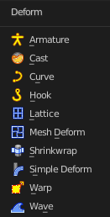

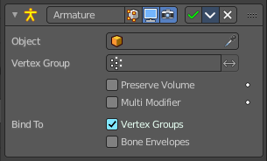
Armature
An armature system allows to deform objects accurately by posing bones. The Armature modifier contains the armature settings at the mesh end.
This modifier gets created automatically when you parent a mesh to an armature.

Object
The name of the armature object used by this modifier.

Vertex Group
A vertex group of the object, which weights will be used to determine the influence of this modifier’s results when mixing it with the results from other Armature ones.
This is only of use when having at least two of these modifiers on the same object, with Multi Modifier activated.

Invert
Inverts the influence set by the vertex group.

Preserve Volume
Use quaternions for preserving volume of object during deformation.
Without Preserve Volume, rotations at joints tend to scale down the neighboring geometry, up to nearly zero at 180 degrees from rest position. With it, the geometry is no longer scaled down, but there is a discontinuity when reaching 180 degrees from rest position.

Multi Modifier
You can parent an object to more than one armature. The Multi Modifier allows you to use several armatures to deform the same object, all based on the “non-deformed” data.
The results of the Armature modifiers are then mixed together, using the weights of the Vertex Group as “mixing guides”.

Bind to

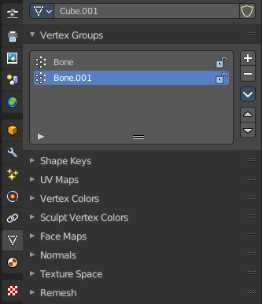
Vertex Groups
Meshes and lattices only. Use Vertex groups for deforming the mesh. A bone named “forearm”, will only affect the vertices in the “forearm” vertex group. The influence of one bone on a given vertex is controlled by the weight of this vertex in the relevant group.
The vertex groups are located in the Object Data Properties in the Properties editor.

Bone Envelopes
Use the Bone envelopes to deform vertices or control points near them, defined by each bone’s envelope radius and distance.
When envelopes are disabled, Blender uses the set of existing vertex group names to determine which bones influences what mesh part.
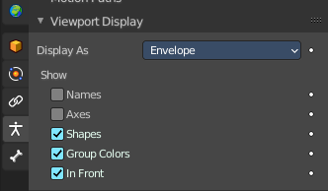
Bone envelopes display can be turned on in the Viewport Display panel in the Object Data properties tab in the Properties Editor. Display as ...

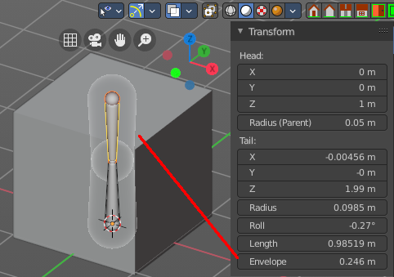
And can be adjusted in the Transform panel in the sidebar of the 3D View, in Edit mode.

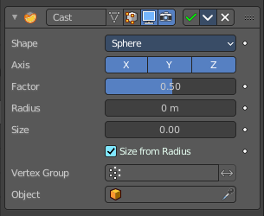
Cast
The Cast modifier shifts the shape of a mesh, curve, surface or lattice object, towards predefined shapes. Sphere, cylinder, cuboid.
Note! For performance reasons, this modifier only works with local coordinates. If the modified object looks wrong, you may need to apply its transformations, especially when casting to a cylinder.

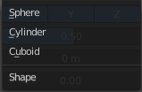
Shape
Choose the target shape of the projection: Sphere, Cylinder or Cuboid.

Axis
The directions in which the modifier works. For a Cylinder shape the Z axis remains unaffected.

Factor
The factor to control blending between original and cast vertex positions.
The factor is a linear interpolation. 0.0 gives original coordinates, and the modifier has no effect then. 1.0 casts to the target shape. Values below 0.0 or above 1.0 exaggerate the deformation.

Radius
A value above 0.0 defines a sphere of influence. Vertices outside it are not affected by the modifier.

Size
Alternative size for the projected shape. If zero, it is defined by the initial shape and the control object, if any.

Size from Radius
Calculate Size from Radius. Can give smoother results.

Vertex Group
Restrict the effect to the vertices in that vertex group.

Invert
Inverts the influence of the selected vertex group.

Object
The name of an object to control the effect. The location of this object’s origin defines the center of the projection. And its size and rotation transform the projected vertices.

Curve
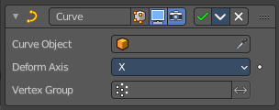
The Curve modifier deforms a mesh along a curve object. You need to have a curve object in the scene, and choose it as the curve object.
The modifier works in global space on a dominant axis, X, Y, or Z. When you move your mesh in the dominant direction, the object will move along the curve. When you pull into the other axis directions then the object will move away from the dominant axis, and deform.
When you move the object beyond the curve’s ends, the object will keep the deformation from the latest curve point.
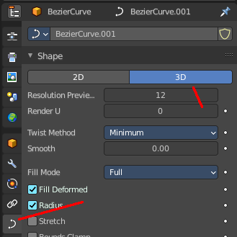
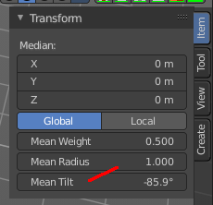
If the curve is 3D, then the rotation of the object can be controlled by the mean tilt of the curve control points. The mean tilt can be found in edit mode in the sidebar in the Transform panel. Other options in the Shape panel can also have an influence at the deforming result. Like Stretch.

Curve Object
The name of the curve object that will affect the deformed object.

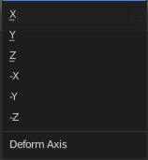
Deformation Axis
The axis to deform along.

Vertex Group
Restrict the effect to the vertices in that vertex group.

Invert
Inverts the influence of the selected vertex group.

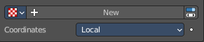
Texture Prop

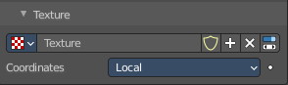
Texture browser
A list of the available textures

Texture Edit Box
The name of the currently active texture. Allows to rename the texture too.

Fake User
Keep this data even when it has no user in the scene.

Add Texture
Add a new texture.

Remove
Removes the texture. Note that the texture is still in the browser list.

Change Context
Jump to texture tab and show the texture.

Coordinates
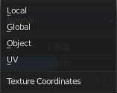
The texture coordinate system to use for the displacement.
The displacement can be along a particular local axis, along the vertex normal. Or the separate RGB components of the texture can be used to displace vertices in the local X, Y and Z directions simultaneously. This is called Vector Displacement.

Direction
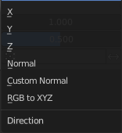
The direction along which to displace the vertices.

X, Y, Z
Displace along an axis.

Space
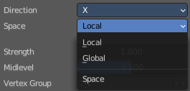
With a direction set to X, Y, Z, or XYZ the modifier can either displace along local or global axes.

Normal
Displace along the vertex normal.

Custom Normal
Displace along (averaged) custom normals, instead of vertex normals.

RGB to XYZ
Displace along local XYZ axes individually using the RGB components of the texture. Red values displaced along the X axis, Green along the Y, Blue along the Z axis.

Space
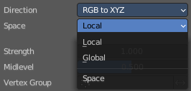
With a direction set to X, Y, Z, or XYZ the modifier can either displace along local or global axes.

Strength
The strength of the displacement. A negative strength inverts the effect of the modifier.
After offsetting by the Mid level value, the displacement will be multiplied by the Strength value to give the final vertex offset.
vertexoffset = displacement × Strength

Mid level
The texture value which will be treated as no displacement by the modifier. Texture values below this threshold will result in negative displacement along the selected direction, while texture values above it will result in positive displacement.
displacement=texturevalue-Midlevel
Note that that color/luminosity values are typically between (0.0 to 1.0) in Blender, and not between (0 to 255).

Vertex Group
Use a vertex group to control the influence of the modifier.

Invert
Inverts the influence of the selected vertex group.

Hook
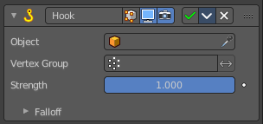
The Hook modifier is used to deform a mesh, curve or lattice by another object. When you move this hook object, then it pulls vertices or control points with it.
Assigning the hook object to specific vertices of the target object is done in Edit mode. The modifier shows a set of buttons then.
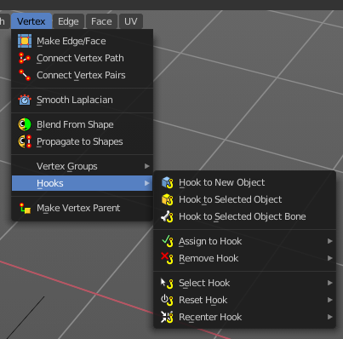
This modifier is automatically created when you add a Hook from the Hooks menu in the Edge menu in edit mode.
Some settings just exists in Edit mode.
Warning! The Hook Modifier stores vertex indices from the original mesh to determine what to affect. Modifiers that generate geometry, like Subdivision Surface, should always be put after the Hook modifier in the stack. Otherwise, the generated geometry can‘ t be affected by the hook’s influence.

Object
The name of the object to hook vertices to.

Vertex Group
Allows you to define the influence per vertex.

Invert
Inverts the influence of the selected vertex group.

Strength
Adjust this hooks influence on the vertices.

Reset
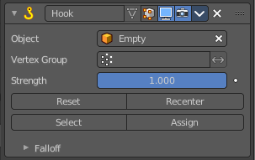
In Edit mode. Recalculate and clear the offset transform of the hook.

Recenter
In Edit mode. Set the hook center to the 3D cursor position.

Select
In Edit mode. Select the vertices affected by this hook.

Assign
In Edit mode. Assigns selected vertices to this hook.

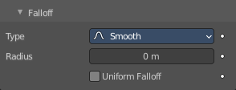
Falloff

Type
This can be used to adjust the kind of influence curve that the hook has on the mesh. You can also define a custom curve to get a much higher level of control.

Radius
The size of the hooks influence.

Uniform Falloff
Compensate non uniform scale, and use a uniform falloff.

Lattice
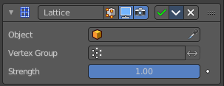
The Lattice modifier deforms the base object by the shape of a Lattice object. It can be used at meshes, curves, surfaces, text, lattices and even particles.
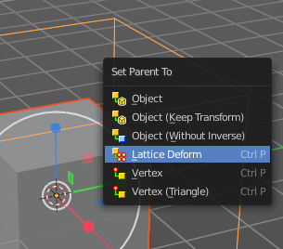
A Lattice modifier with valid settings can be added by selecting the object, holding down shift, select the target lattice object, and then choose Lattice Deform in the Parent menu.
Note! When you want to use a lattice to deform particles, then you need to place the Lattice modifier after the Particle System modifier.

Object
The Lattice object that deforms the base object.

Vertex Group
Limit the modifier’s effect to a vertex group of the base mesh.

Invert
Inverts the influence of the selected vertex group.

Strength
A factor to control blending between original and deformed vertex positions.

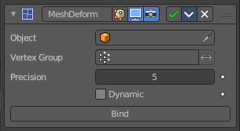
Mesh Deform
The Mesh Deform modifier allows an arbitrary mesh of any closed shape to act as a deformation cage around another mesh.
Note! The changes are not displayed in edit mode. But Edit mode is where you deform your cage object.
Note! This modifier can run out of memory and crash.

Object
The name of the mesh object to be used as the deforming cage.

Vertex Group
Restrict the affected vertices to a vertex group.

Invert
Inverts the influence of the selected vertex group.

Precision
Controls the accuracy with which the deform mesh cage alters the deformed object when the points on the cage are moved. Higher values means better precision and higher calculation time.
This setting is unavailable once a cage has been bound.

Dynamic
When activated, other mesh altering features (such as other modifiers and shape keys) are taken into account when binding. This increases the deformation quality.
This setting is unavailable once a cage has been bound.

Bind
Bind the current vertex positions of both, the modified geometry and the deforming Object, together. An unbound Mesh Deform modifier has no effect. It must be bound so that altering the shape of the deform mesh cage is able to alter the shape of the modified object.
Warning! It can take a long time for the operation to complete. And the software may not respond for a pretty while.

Unbind
Unbind the meshes. The deformed object will reset back to its original shape that it had before it was bound to the deform mesh cage.

Shrinkwrap
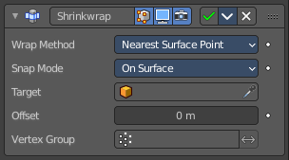
The Shrinkwrap modifier allows an object to “shrink” to the surface of another object. It moves each vertex of the object to the closest position on the surface of the target object.
It can be applied to meshes, lattices, curves, surfaces and texts.

Wrap Method
The method to determine the nearest point on the target’s surface for each vertex of the object.

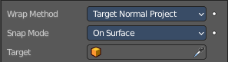
Nearest Surface Point + Target Normal Project
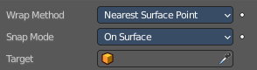
Nearest Surface Point selects the nearest point at the surface. Additionally, Target Normal Project tries to match the interpolated normals of the surface.

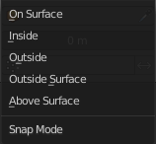
Snap Mode
How the vertex snaps to the surface. The methods should be self explaining.

Target
The target mesh to shrink to.

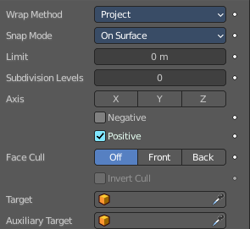
Project
Projects all vertices along a chosen axis until they hit the surface of the target object.
Vertices that never hits the surface are not calculated.

Snap Mode
How the vertex snaps to the surface. The methods should be self explaining.

Limit
A distance limit between original vertex and surface. If the distance is larger than this limit vertex would not be projected onto the surface.

Subdivision Levels
This applies a (temporary) Catmull-Clark subdivision to the modified object’s geometry, before computing the wrap.

Axis
Along which local axis of the modified object the projection is done. These options can be combined with each other, yielding a “median axis” of projection. If none are selected, the normal direction is used.

Negative/Positive
This allows you to select the allowed direction(s) of the shrink along the selected axis. If both options are enabled, both ways are evaluated and the closest hit is selected.

Face Cull
Allows you to prevent any projection over the “front side” or the “back side” of the target’s faces. The “side” of a face is determined by its normal.

Target
The target mesh to shrink to.

Auxiliary Target
An additional object to project to.

Nearest Vertex
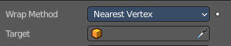
Snaps to the nearest vertex instead of the nearest surface point.

Target
The target mesh to shrink to.

Offset
An offset distance to keep to the target surface.

Vertex Group
Restrict the affected vertices to a vertex group.

Invert
Inverts the influence of the selected vertex group.

Simple Deform
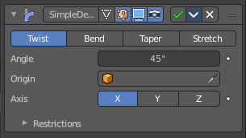
The Simple Deform modifier allows simple deforming of an object of type Mesh, lattice, curve, surface and text.
The deformation is calculated in local coordinate space.

Deform Method

Twist
Twist rotates the object around an axis. Vertices in the same plane as the origin are not rotated. Above the origin the rotation is clockwise. Below the origin the rotation is negative. The amount of rotation is dependent of the distance to the origin. Closer vertices rotates not so strong.

Bend
Bend bends the object over an axis.

Taper
Taper tapers the object across its origin. The scaling factor is weighted by the distance from the origin of the object in the deform axis.

Stretch
Stretch scales the object along an axis.
Angle (Twist & Bend) / Factor (Taper & Stretch)
The total amount of deformation. A negative value reverses the deformation.

Origin
Pick an object to use its origin as the origin for the simple deformation.

Restrictions

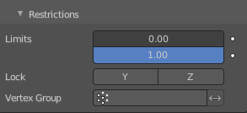
Limits
You can set lower and upper limits for the deformation. The upper limit cannot be lower than the lower one. These limits are mapped on the Deform axis.

Lock
Not for Bend. Do not allow deformations along these axis.

Vertex Group
Limit the deformation to a vertex group.

Warp
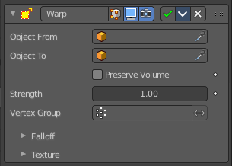
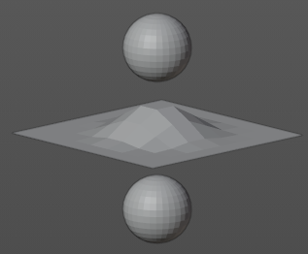
The Warp modifier warps parts of a mesh to a new location by using two target objects. The deformation goes into the direction from the first target object to the second target object. This target objects can be of any type. Empty, Lamp, Camera, etc. For demonstration purposes two spheres are used.

Object From
The object to define the origin transformation of the warp.

Object To
The object to define the destination transformation of the warp.

Preserve Volume
Enables volume preservation when rotating one of the transforms.

Strength
Sets how strong the effect is.

Vertex Group
Limit the modifier to a vertex group.

Invert
Inverts the influence of the selected vertex group.

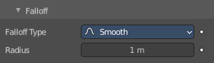
Falloff

Falloff Type
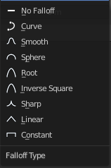
The falloff type. How the strength of the warp changes as it goes from the center of the transform to the Radius value.

Radius
The distance from the transforms that can be warped by the transform handles.

Texture
A texture allows you to control how the vertices are affected by the modifier.

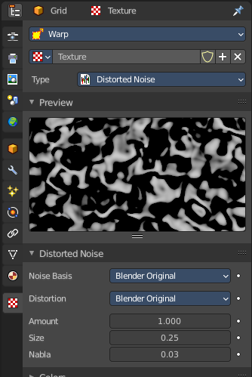
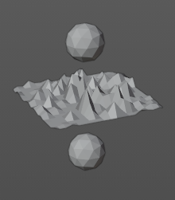
Usage
Add a texture.
Head over to the Texture tab.
In the texture tab either load an existing texture. Or create one. A procedural Noise texture for example.

Texture Prop

Texture browser
A list of the available textures

Texture Edit Box
The name of the currently active texture. Allows to rename the texture too.

Fake User
Keep this data even when it has no user in the scene.

Add Texture
Add a new texture.

Remove
Removes the texture. Note that the texture is still in the browser list.

Change Context
Jump to texture tab and show the texture.

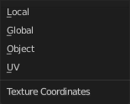
Coordinates
What texture coordinate system to use.

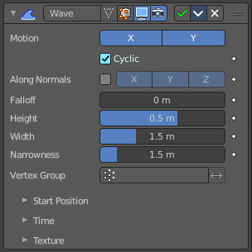
Wave
The Wave modifier adds a ripple-like shape to an object’s geometry. The shape can be animated by playing the animation.
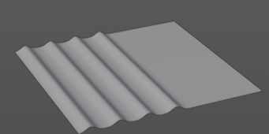

This modifier works with meshes, lattices, curves, surfaces and texts.
Important! All the values are in local object space. They must be multiplied with the corresponding Scale values of the object to get the real dimensions.
To obtain a nice wave effect similar to sea waves and close to a sinusoidal wave, make the distance between following ripples and the ripple width equal. That is, the Narrowness value must be equal to 2 / Width. E.g. for Width to be 1, set Narrow to 2.

Motion
The wave effect deforms vertices/control points in the Z direction. The initial start point is the object origin. The direction is then in X or Y direction. With both activated you get a circle shape.

Cyclic
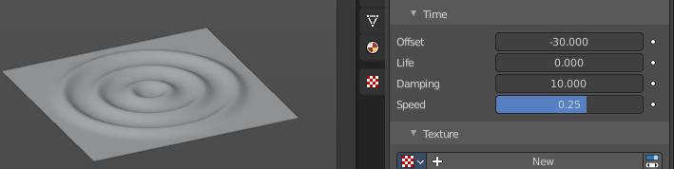
Repeats the waves.
When you want to have more circles at frame 1 already, then use a negative Offset in the Time subpanel.

Along Normals
For meshes only. Displaces the mesh along the surface normals (instead of the object’s Z axis).

X/Y/Z
Restrict displacement along normals to the selected local axes.

Falloff
Controls how fast the waves fade out as they travel away from the starting point.

Height
The height or amplitude of the ripple.

Width
Distance between the waves. If the pulses are too near to each other, the wave may not reach the zero Z position. In this case the whole wave gets lowered so that the minimum is zero, and the maximum is lower than the expected amplitude.

Narrowness
The actual width of each pulse.
The higher the value the narrower the pulse. The actual width of the area for a single is given by 4 / Narrowness.

Vertex Group
Limit the effect of the modifier to a vertex group.

Invert
Inverts the influence of the selected vertex group.

Start Position

Object
Use the origin of another object as the starting point.

Start Position X/Y
Coordinates of the center of the waves, in object’s local space.

Time
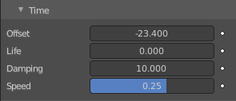
Settings to control the animation.

Offset
Time offset in frames. The frame at which the wave begins (if Speed is positive), or ends (if Speed is negative). Use a negative frame number to prime and pre-start the waves.

Life
Duration of animation in frames. With a value of zero the animation loops forever.

Damping
An additional number of frames in which the wave slowly damps from the Height value to zero after Life is reached. The dampening occurs for all the ripples and begins in the first frame after the Life is over. Ripples disappear over Damping frames.

Speed
The speed per frame, of the ripple.

Texture subtab
A texture allows you to control how the vertices are affected by the modifier.

Usage
Add a texture.
Head over to the Texture tab.
In the texture tab either load an existing texture. Or create one. A procedural Noise texture for example.

Texture Prop

Texture browser
A list of the available textures

Texture Edit Box
The name of the currently active texture. Allows to rename the texture too.

Fake User
Keep this data even when it has no user in the scene.

Add Texture
Add a new texture.

Remove
Removes the texture. Note that the texture is still in the browser list.

Change Context
Jump to texture tab and show the texture.

Coordinates
What texture coordinate system to use.

